Report of Practical 9
Runtime Results
Algorithm | Order | 8.000 | 32.000 | 128.000 | 512.000 | 2048.000 | 8192.000
MergeSort | Ascending | 2.333 | 10.333 | 207.667 | 54.000 | 188.000 | 934.000
MergeSort | Descending | 2.667 | 9.667 | 203.000 | 59.000 | 184.333 | 927.000
MergeSort | Random | 2.000 | 11.000 | 61.667 | 58.667 | 435.000 | 991.333
MergeSort | Neatly Sorted | 5.667 | 12.333 | 252.000 | 138.333 | 1022.000 | 3671.333
QuickSort (Left-most pivot) | Ascending | 1.667 | 9.000 | 145.667 | 344.333 | 4917.333 | 16582.000
QuickSort (Left-most pivot) | Descending | 1.000 | 13.667 | 185.000 | 334.333 | 5962.667 | 23733.667
QuickSort (Left-most pivot) | Random | 1.000 | 6.333 | 58.667 | 350.000 | 329.000 | 4477.333
QuickSort (Left-most pivot) | Neatly Sorted | 3.000 | 7.000 | 44.000 | 94.667 | 357.000 | 1569.000
QuickSort (Median of 3) | Ascending | 1.667 | 4.333 | 27.333 | 40.333 | 65.333 | 452.000
QuickSort (Median of 3) | Descending | 1.000 | 6.000 | 36.667 | 56.000 | 66.000 | 611.667
QuickSort (Median of 3) | Random | 1.000 | 5.000 | 42.000 | 113.333 | 130.000 | 304.667
QuickSort (Median of 3) | Neatly Sorted | 2.000 | 7.333 | 28.333 | 55.000 | 166.667 | 634.333
QuickSort (Random pivot) | Ascending | 4.000 | 14.000 | 60.000 | 116.333 | 129.000 | 421.000
QuickSort (Random pivot) | Descending | 2.000 | 17.000 | 57.000 | 167.667 | 101.667 | 400.667
QuickSort (Random pivot) | Random | 2.667 | 12.000 | 61.000 | 119.333 | 164.333 | 402.667
QuickSort (Random pivot) | Neatly Sorted | 13.333 | 9.000 | 22.667 | 56.000 | 189.000 | 947.000

Graph of result
Ascending order
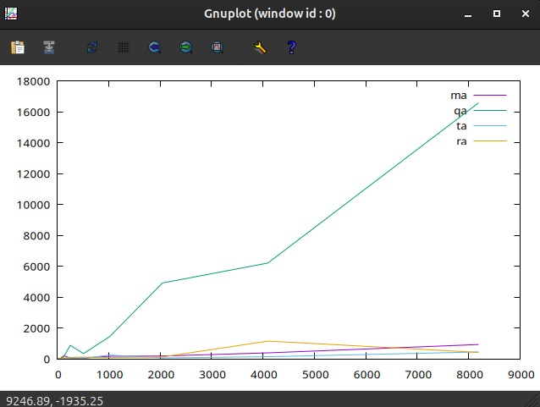
Descending order
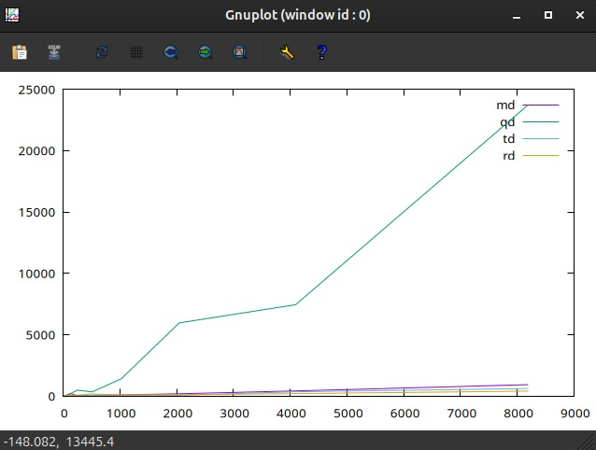
Neatly Sorted
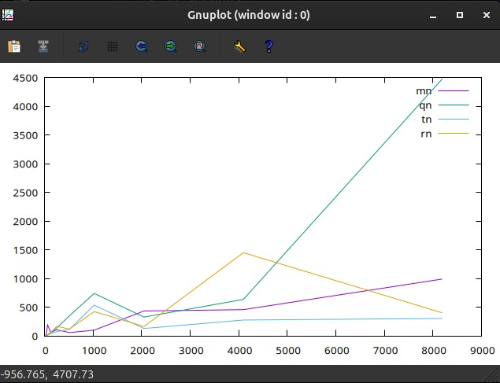
Random Order
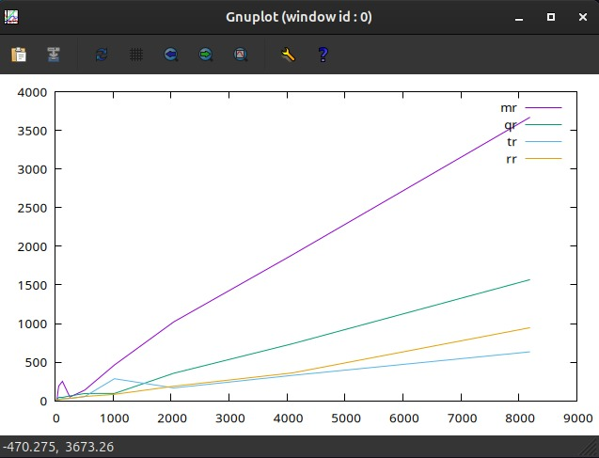
Complexity Comparison
Algorithm | Ascending | Descending | Random | Neatly Sorted
MergeSort | O(n log n) | O(n log n) | O(n log n) | O(n log n)
QuickSort (Left-most pivot) | O(n²) | O(n²) | O(n log n) | O(n²)
QuickSort (Median of 3) | O(n log n) | O(n log n) | O(n log n) | O(n log n)
QuickSort (Random pivot) | O(n log n) | O(n log n) | O(n log n) | O(n log n)

Cases Summary
Algorithm | Best Case | Average Case | Worst Case
MergeSort | O(n log n) | O(n log n) | O(n log n)
QuickSort (Left-most pivot) | O(n log n) | O(n log n) | O(n²)
QuickSort (Median of 3) | O(n log n) | O(n log n) | O(n²)
QuickSort (Random pivot) | O(n log n) | O(n log n) | O(n²)

Conclusion:
The experiment confirms the theoretical practice of MergeSort and QuickSort.
- MergeSort provides stable O(N log N) performance for all input types but requires additional memory.
- QuickSort using the left-most node as pivot is highly vulnerable to the worst-case of O(n²) behavior when handling sorted or reverse-sorted arrays.
- Random pivot QuickSorting improves average performance by reducing the predictable of bad partitions.
- QuickSort uses the median-of-three strategy to deliver the best overall performance and consistency, making it the most efficient approach in this comparison test.
Therefore, for practical applications:
- MergeSort is most preferable when guaranteed stability and performance are important.
- QuickSort with median-of-three pivot selection is the most efficient general-purpose sorting method among the tested implementations.

Reported by:
Andrew (23657586) and Matthew (23439784)

